BCPTA Conference 2015

Nonfiction Writing Power:
Writing with Information with Intent

Adrienne Gear
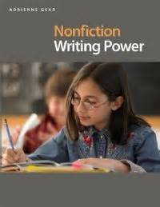

Contact Adrienne:
Email: Adrienne@readingpowergear.com
Website: www.readingpowergear.com
Blog: www.readingpowergear.blogspot.com
Facebook: www.facebook.com/readingpowergear
Twitter: @AdrienneGear

Nonfiction Writing Power
Adrienne Gear

What is Writing Power? - Writing with intent and purpose; “we write to invite thinking”; shifting the focus of writing to get a mark to “writing for the reader”.

My Writing Goals

- Make sure my writing is INTERESTING
- Interesting details
- Interesting words
- Similes
- Voice
Text Features
- Make sure my reader is not CONFUSED!
- Spelling
- Punctuation
- Spacing
- Organization

Nonfiction Writing Techniques:
- Triple Scoop Words – increasing vocabulary
- Add a Detail! – no more robot writing!
- Nonfiction Features – show what you know in a different way
- Hooking Your Reader – great opening sentences
- Let’s Get Organized! – understanding text structures
- Simile and You Will See! – using comparisons
- Great First Impressions – great beginnings
- Voice

4 Key elements of Nonfiction Writing Forms:
- Purpose - Who is my reader and what is my intention for writing?
- Text Structure - What is the specific structure (skeleton) of this writing form?
- Language Features - What specific language (words or phrases) is featured?
- Writing Techniques – Which writing techniques can I teach that would help to enhance the quality of this particular form of writing?
- Topic Forms - What non-fiction features could be included (labels, diagrams)
- Anchor Books – Which books can I use to model specific forms or techniques?

 | COMPARING TEXT STRUCTURE
FICTION | NONFICTION
“Walking stories” | Description | Intent: Provide reader with facts and information about a topic | Reports on countries, animals, plants, insects, wanted poster
“Climbing stories”  Stories, myths, legends | Instruction | Intent: Provide reader with instructions on how to achieve a goal, do something, make something, get somewhere | Recipes, directions, games, maps, rules, experiments, crafts, drawing, lists, letters
 | Persuasion | Intent: Provide reader with an opinion, facts and evidence to convince them to take an action of some kind | Advertisements, travel brochures, debates, opinions, catalogues, posters
 | Comparison | Intent: Provide reader with similarities and differences between two topics or ideas. | Similarities and differences between two or more things; can incorporate persuasion
 | Explanation | Intent: Provide reader with facts explaining how or why something happens. | Scientific explanations, phenomenon, elaborations.
 | Nonfiction Narrative | Intent: Provide reader with sequential description of events in a person’s life, current or historical event. | Retelling about a person’s life (biography) or a past event (news report) in sequential order

Description | Instruction | Persuasion | Comparison | Explanation | Biography
What?  What?  What?  What?  What? | What?  What?  How? | What?  Why?  Why?  Why?  What was that again? | Both  Same  Different  End | How?  Why?  Because  (Because)  SO THERE! | Who?  What?  Where?  When?  How?  Wow!

Nonfiction Writing Power – Recommended Book List:

Professional Resources:

Is That a Fact? – Tony Stead
A Sense of Wonder – Georgia Heard
Nonfiction Craft Lessons – Ralph Fletcher
What’s Next for This Beginning Writer? - Janine Reid
Marvellous Mini Lessons – Lori Jamison Rogg (books available for Primary and Inter.)
Writing Power/Nonfiction Writing Power – Adrienne Gear

Instruction:
How To Read a Story – Kate Messner
Scaredy Squirrel (any book) – Melanie Watt
Imagine You’re A… (series includes Pirate, Wizard, Astronaut, Princess, Fairy)- Lucy & Meg Clibbon
How To Lose All Your Friends – Nancy Carlson
Everyone Can Learn How to Ride a Bicycle – Chris Raschka
How to Teach a Slug to Read – Susan Pearson
Beginner’s Guide To Running Away From Home - Jennifer Larue Wuget
My Soccer Book – Gail Gibbons (also similar books on baseball and football)
How A House is Built – Gail Gibbons
11 Experiments that Failed – Jenny Orliff
Eddie Gets Ready – David Milgram
Smashed Potatoes – Jane G. Martel
Instructions – Neil Gaiman
How to Babysit a Grandpa – Jean Reagan (also How to Babysit a Grandma)
How To Be A Cat – Nikki McClure
How to Be A Dog – Jo Williamson
How To Be – Laura Brown
How To – Julie Morstad
The Astronaut Handbook – Meagan McCarthy
Some Tips for a Better World and a Happier Life – Rebecca Doughty
10 Things I Can Do to Help My World – Melanie Walsh
My Green Day – Melanie Walsh

Persuasion:
The Day the Crayons Quit – Drew Daywalt
The Day the Crayons Came Home – Drew Daywalt
I Wanna Iguana – Karen Orloff
I Wanna New Room – Karen Orloff
Earings! – Judith Voirst
Dear Mrs. LeRue – Mark Teague
I Wanna Pet – Lauren Child
My Brother Dan’s Delicious – Steven Layne
Free as the Wind – Saving the Horses on Sable Island – Jamie Bastedo
Hey, Little Ant! – Philip and Hannah Noose
Should There Be Zoos? – Tony Stead
Should We Have Pets? – Sylvia Lollis
Have I Gotta Book for You! – Melanie Watt
Click Clack Moo – Doreen Cronin
How to Negotiate Everything! - Lisa Lutz

Explanation:
Why Do Leaves Change Color (Let’s Read and Find Out About Science series) – Betsy Maestro
That’s How – Christopher Niemann
Just So Stories – Rudyard Kipling
National Geographic Little Kids First Big Book of Why – Amy Sheilds
Why Do We Have Day and Night? – Peter Neumeyer
I Wonder Why?... (series) – Kingfisher
What Makes Day and Night? – Franklyn Branley
Why Do Leaves Change Color? – Betsy Maestro
How Do Apples Grow? –Betsy Maestro
Why? The Best Ever Question and Answer Series – Catherine Ripley
How? - Catherine Ripley
Head-to-Toe Body Questions – Anna Claybourne (Crabtree Connections series)
Tadpole Story – Anna Claybourne
Why I Sneeze, Shiver, Hiccup and Yawn – Melvin Berger
Where Does Pepper Come From? And Other Fun Facts – Bridgette Raap

Comparison:
What’s the Difference? 10 Animal Look-Alikes – Judy Diehl and David Plumb
National Geographic Readers: Cats. Vs. Dogs – Elizabeth Carney
Country Kid, City Kid – Julie Cummins
The Sun, the Wind and the Rain – Lisa Westburg Peters
Alligator Vs. Crocodile: Animals Head to Head – Isabel Thomas (this is a series)
Are Trees Alive? – Debbie S. Miller
Same, Same but Different – Jenny Sue Kostecki-Shaw
We’re Different, We’re the Same – Bobbie Katz
Dog Vs. Cat – Chris Gal
Pirates Vs. Cowboys – Karen Reynolds
Lion Vs. Rabbit – Alex Latime

Nonfiction Authors with Voice
Nicola Davies – Tiny Turtle, Surprising Shark, Bat Loves the Night
Are You A …? - Backyard books – Judy Allan (bee, ant, grasshopper, ladybug)
Creature Features – Steve Jenkins
Who’s Like Me ? - Nicola Davies (interactive “lift the flap” books)
Gentle Giant Octopus – Karen Wallace
The Emperor’s Egg – Martin Jenkins
Creature Features – Steve Jenkins
Disgusting Creature Series – Elise Gravel

Notes…

3,2,1 – Check It!

3 – Convention Correction
Spelling, punctuation, spacing
2 – Word Wind-Up:
Add, erase, replace
1 – Sentence Shake-Up:
Add, erase, replace - to
make your sentence sound better

No Excuse” Spelling Lists
Grade 1 – “No Excuse” Words
a | for | on
am | he | she
and | I | that
are | in | the
at | is | to
be | it | was
can | of | you

Grade 2 – “No Excuse” Words
a | from | is | they
all | had | it | this
am | have | not | to
and | he | of | was
are | her | on | we
as | his | one | this
at | I | or | were
be | in | she | where
can | it | that | with
for | in | the | you

G rade 3 – “No Excuse” Words
a | for | on | they
about | have | one | this
all | had | or | to
am | he | other | up
an | her | out | was
and | his | said | we
are | how | she | were
as | I | so | what
at | if | some | when
be | in | that | which
but | is | the | why
can | it | their | will
could | many | them | with
do | not | there | would
each | of | these | you
every | off | they | your

Nonfiction Text Structures

DESCRIPTIVE WRITING
PURPOSE:
- To share information and facts about a particular topic with the reader
- To give a general description (reports on animals, plants, machines)
- To give a specific description (reports on a specific animal, plant, planet, etc.)
TEXT STRUCTURE:
Remember to “fill your drawers!”
- WHAT?
- WHAT?
3. WHAT?
4. WHAT?
5. WHAT?
LANGUAGE FEATURES:
- Use of action words (run, erupt, bloom)
- Use of linking verbs (is, are, belong, to)
- Use of descriptive words (size, color, shape, texture)
- Use of factual description
- Inclusion of diagrams, labels, pictures and drawings
EXAMPLES:  - Reports about animals, countries, planets, insects, etc.  - Reports about specific animals, plants, insects, countries | - General topic – “Bears”  - Specific topic – “Grizzly Bears”

Let’s Get Organized!

Web Planner

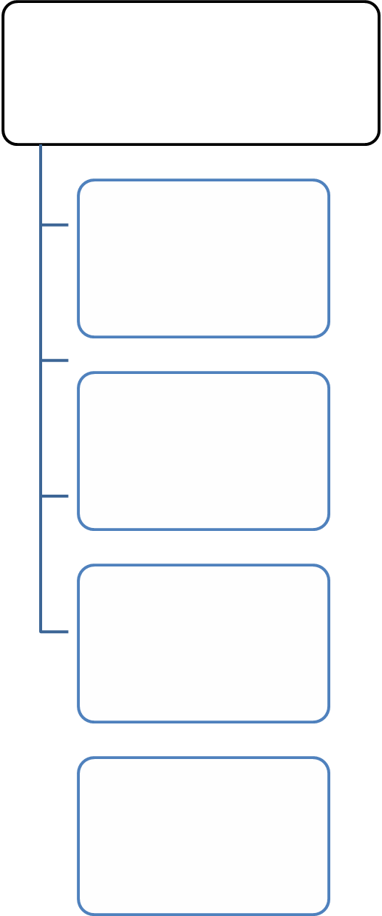

Instructional Writing
PURPOSE:
- Tell the reader HOW to achieve a particular goal
- Tell the reader HOW to follow a set of directions or procedures.
TEXT STRUCTURE: The (“What? What? How?)
1. WHAT? - is being achieved
2. WHAT? - do you need (materials, ingredients or equipment)
3. HOW? - do you do it (numbered steps, diagrams, illustrations, labels)
LANGUAGE FEATURES:
- Action words: put, let, stir, shake, kick, push, hold
- Details: (color, amount, size, time)
Put in one cup; take the red square; squeeze a small amount; go through the big door)
- Details: (how, when and where)
Cut carefully; after rolling the dice; two centimeters from the top
- Second Person:
You take the ball; fold the paper
EXAMPLES:  - How to make a fruit salad  - How to play checkers  - How to brush your teeth  - How to tie your shoelaces  - How to plant a seed (bulb)  - How to be a friend  - How to get to school  - How to measure your height  - How to make a birthday card | - How to write a story  - How to play 7-up  - How to make a jam sandwich  - How to draw an apple  - How to make your mom happy  - How to make your bed  - How to make a kite  - How to wrap a present  - How to make a milkshake
How to: _____________________________
What you will need:

Steps:
- ______________________________________________________________________________________
- ______________________________________________________________________________________
- ______________________________________________________________________________________
- ______________________________________________________________________________________
- ______________________________________________________________________________________
- ______________________________________________________________________________________

TIPS: _________________________________________________________________________________________________

WHAT: How To ___________________________
WHAT you will need:

___________________

___________________
___________________

___________________

___________________

___________________

___________________

___________________

HOW to ________________________________
1 | 2 | 3
4 | 5 | 6

