BCPTA Conference 2015

Effective Writing Instruction K-1 – Adrienne Gear

Term 1 - ***Keep it simple!***

*Read LOTS of books to them! Talk about the writing – describe what you notice about the writing.*

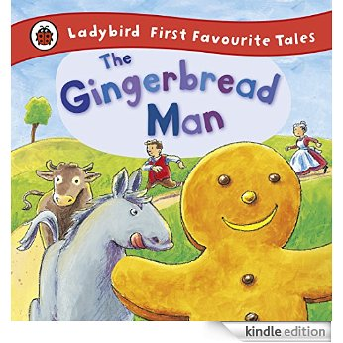ie: Gingerbread Man – *“I notice that there is a repeating line in the story. Repeating lines make the story interesting to me.”*

ie. Read a wordless picture book *– “I notice that there are no words in this book but we can still read the pictures”*

ie. Read a book where animals are talking – *“I notice that this book has animals who talk like people. The author is very imaginative.”*

ie. Read a nonfiction book *- “I’m noticing the pictures in here look different than the ones in this… book”.*

**Writing Activity – pattern writing**

Students write “STOP!” said \_\_\_\_\_\_\_\_\_\_\_\_\_\_\_\_\_\_ (their name) to the gingerbread man. They draw a picture of him/herself running after gingerbread man. Make a class book.

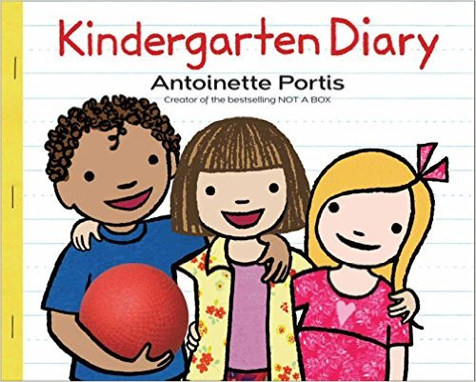**Start a Journal**

* Read Kindergarten’s Diary – mouse writing journal entries.
* Explain that journal writing is one way people get to share their stories about themselves and things that happen to them. *“You are all writers because you can share your stories too”.*
* Some may *say “I don’t know how to write”* Respond*: “That’s Okay Authors often use pictures to help them tell their story.”* Show wordless books or books that just have one word in them (Hug – Jez Alborogh; Look! Jeff Mack)
* Model writing a journal entry. Begin with a picture – explain that drawing a picture helps you write. Then model different ways to write – labeling the pictures, writing one word, writing a sentence.
* Challenge – write about one thing you did over the summer in your diary: camping, visit grandparents, going on a plane. Draw a picture and do your best writing.
* Walk around and have students tell them your story. Respond with either a sentence or scribe their sentence. “Your uncle’s farm sounds fun.” Response is preferred over scribing because it tells students you understand.
* Use this first entry as a baseline for what students already know (or don’t know ) about writing.

**DIFFERENT KINDS OF PRINTING –**

Explain that there are different kinds of printing Kindergarten students can use:

* **Swirly (Scribble) Printing** – (model “pretend” writing with loops and lines)
* **Letter Printing** – when you start to write down letters in a line but often they is no sound-letter correspondence. Draw a picture and model a string of letters.
* **Sound Printing** – when start to write words that match the sound
* (I sometimes call this **“bubble gum printing**” because you have to “Stretch” the word out like a piece of bubble gum to hear all the sounds. Model this!)
* **Book Printing** – when your printing looks like the printing in a book – with big and small letters, spaces, etc. (show printing in a book) Model on the board. (I sometimes call this ***“Spaghetti and Meatball Printing”*** – spaghetti spaces between letters and meatball spaces between words)

**Brain Pockets**

* Explain that writers have different purposes for writing books – sometimes they want to share a personal story or memory (like their journal), others like to write facts about things, and others like to use their imagination to create new ideas. Just like some children like to read and write about about cars and planes and others might like to read and write about princesses and fairies.
* [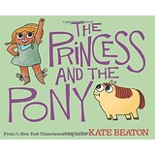](http://www.amazon.ca/The-Princess-Pony-Kate-Beaton/dp/0545637082/ref=pd_sim_sbs_14_4?ie=UTF8&refRID=0K363GASWTC0W9695HJG)Hold up 3 books to see if they can distinguish a memory book, fact book and imagination book.

[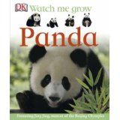](http://www.amazon.ca/Panda-Fleur-Star/dp/1405328673/ref=sr_1_16?s=books&ie=UTF8&qid=1442464885&sr=1-16&keywords=panda)[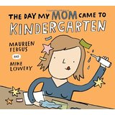](http://www.amazon.ca/The-Day-Mom-Came-Kindergarten/dp/1554536987/ref=pd_sim_14_7?ie=UTF8&refRID=19BA34G1NZD8HPGGWAAT)

* Draw a brain on the board and divide into three parts – talk about where writers get their ideas for writing – memory pocket, fact pocket, imagination pocket.

**Lesson 1** – What ideas do have in your memory pocket that you could write about? (draw example – maybe a tent for camping; mountain for skiing; cut my finger)

[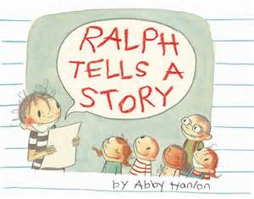](http://www.bing.com/images/search?q=ralph+writes+a+story&view=detailv2&&id=8EE691A5C89B7C89EBA172D7D5D4AD9C39E6D626&selectedIndex=0&ccid=aDiCi5V8&simid=607987062805235786&thid=JN.OxD4kQeq/vLMrXujgd2EtQ)Read – ***Ralph Writes a Story*** – Abby Hanlon (great example about using our memory pockets for writing)

* Pass out large Brain pocket papers – invite students to draw (and label) ideas for what they could write about

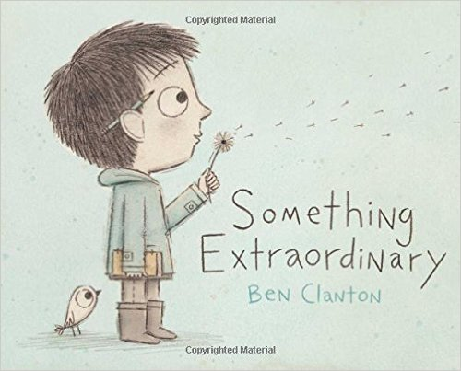**Lesson 2 – Fact Pocket** – what facts do you know a lot about? Canada, hockey, dinosaurs, horses. Model some examples.

**Lesson 3 – Imagination Pocket** - most kids love this pocket! What sort of imaginary things could you write a story about? Magic, princesses, flying, being invisible, living in a computer game, etc. Display Brain Pockets as kids love to see what others have drawn or written about

Read – ***Something Extraordinary*** by Ben Clanton

**Linking Reading with Writing - MAKING CONNECTIONS**

Read “connect” books regularly (once or twice a week) and have students write about their connections

* *My Blue is Happy* - Jessica Young – connection to a color
* *Too Many Toys!* – David Shannon - connection to toys they would keep and give away
* *The OK Book* – Amy Krouse Rosenthal - connection to something they are “OK” at
* *The Cat’s Pajamas* – Catherine Forman connection to their pajamas
* *It’s OKAY to Make Mistakes* – Todd Parr - connection to a mistake they sometimes make
* *It’s Not Fair!* – Amy Krouse Rosenthal – connection to something they think isn’t fair
* *My Brave Book of Firsts* – Jamie Lee Curtis – connection to something they have done for the first time
* *100 Things That Make Me Happy* – Amy Schwartz– connection to something that makes them happy
* *Waiting* – Kevin Henkes connections to something they have to wait for
* *Sometimes You Barf* – Nancy Carlson (connecting to throwing up)

**No More ROBOT WRITING!**

**Strategy** – List, Sort, Label

* Around mid October- bring in a pumpkin.
* Ask students to tell you words to describe the pumpkin. Write the words on a chart stand.
* Ask if they can see any words that might go together or belong in the same word family? (ie. *Orange, green, white* can be grouped together; *big, round; bumpy, smooth, cold ,* etc. Re-write the words into groups .
* Ask what would be a good title (label) for the groups? Write title at the top of the group (ie. **COLOR**; **SIZE**, etc)
* Tell the students that when writers are writing, they often use these detail words to make their writing more interesting.
* Write: *I like pumpkins*. This sentence is boring. It sounds like a robot. (use a robot voice and actions) But I could choose one of these words from this list to make my sentence more interesting*. I like big, orange pumpkins*.

**TRIPLE SCOOP WORDS**

* Explain that another way writers make writing interesting is using triple scoop words. Triple scoop words are delicious, just like triple scoop ice cream cones! There are lots of words in the world but triple scoop words are the best!
* Refer to the words on the pumpkin chart. I like to use the word “big” as the example
* Make a chart:

|  |  |
| --- | --- |
| [http://tse1.mm.bing.net/th?&id=JN.hpH8ImKTublobYWHf7xQnA&w=300&h=300&c=0&pid=1.9&rs=0&p=0&r=0](http://www.bing.com/images/search?q=ice+cream+cone+drawing&view=detailv2&&id=B7E236E4EF130518ED08056D742A8756832580B1&selectedIndex=42&ccid=uqYADxEt&simid=607995949099322997&thid=JN.hpH8ImKTublobYWHf7xQnA) | C:\Users\pcuser\AppData\Local\Microsoft\Windows\INetCache\IE\5ICN6NKH\Three-Scoop-Ice-Cream-Cone-5351-small[1].png |
| big | humungous  gigantic  enormous |

* Make an anchor chart : “Ways to Help Me Be a Better Writer”

Bubble Gum printing – sound it out

Spaghetti and Meatball spaces

Add detail words

Add triple scoop words

* Mother’s Day – draw a picture of your mother and describe her using one triple scoop word!
* From there, encourage students to use details/triple scoop words in their journals.
* When conferencing with students about their journal writing use a mini self assessment

(One side for student/ one side for teacher)

******[](http://www.bing.com/images/search?q=emoji+sad+face&view=detailv2&&id=33BDA796AA3B8EDAFE2C44FA2E893494BB3BFAA1&selectedIndex=1&ccid=b268Hq2X&simid=608015955054887973&thid=JN.qbSNOJavZluXRZeDg%2bsuzg)Happy Face OKAY Face Sad Face**

* My picture and my story:

I tried to sound out some letters and words on my own

I tried to add one detail to my writing to make it more interesting

I tried to use a triple scoop word in my writing

I tried to remember finger spaces between my words

* Student color in face and teacher colors the other one
* Talk about one thing student can do – write a goal
* Staple assessment to one journal entry so they can show parents in conference)

**Term 2 – Focus on Writing Longer pieces**

**Walking story and Climbing story**

**TOPICS**

* I LIKE ME – lesson
* My Friend
* [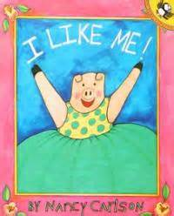](http://www.bing.com/images/search?q=I+Like+Me+-+Nancy+Carlson&view=detailv2&&id=78EBF6D38FA3CDDBBE457AEB2A9DDDED01621C7C&selectedIndex=1&ccid=pFWFx5Lu&simid=607995145940631949&thid=JN.0YWoVnYIdNg4W7OYWRzIxQ)A Special Grown Up

Students make “mini books” about themselves

Read ***I Like Me*** by Nancy Carlson

Use “anchor line” or repeating line “I Like Me!”

Make a booklet form:

* Page 1 – I like me!
* Page 2 – I like my \_\_\_\_\_\_\_\_\_\_\_\_ (physical feature)
* Page 3 – I can \_\_\_\_\_\_\_\_\_\_\_\_\_\_\_\_\_\_\_\_\_ (something they are good at – with detail)
* Page 4 I like \_\_\_\_\_\_\_\_\_\_\_\_\_\_\_ (something they like – can be food, activity, game, sport)
* Page 5 – I am \_\_\_\_\_\_\_\_\_\_\_\_\_ (triple scoop description word – “awesome”, “fantastic” “helpful”
* [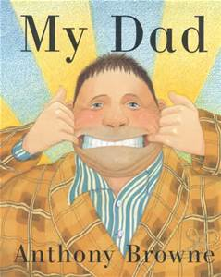](http://www.bing.com/images/search?q=my+dad+anthony+browne&view=detailv2&&id=1F91608822F38B11FA0C12DD86E2DF5A76174714&selectedIndex=0&ccid=QK1iNOst&simid=608042111408866061&thid=JN.QTE71L/djLSSnQBq03MXgg)Page 6 I like ME!

Once booklets are complete with pictures, students can share in the “Author’s Chair”

Repeat next lesson, students write about a Special Grown UP – Read “My Dad by Anthony Brown.

**INTRODUCE VISUALIZING** – Making Pictures In Your Head

* Practice visualizing with books you are reading. Comment “When the author describes the beach, I can really see that in my mind” Talk about describing using the senses – smells, sounds, tastes, etc.

**Write about My Special Place.**

Anchor Book: The Hello Good-bye Window or The Seashore Book

[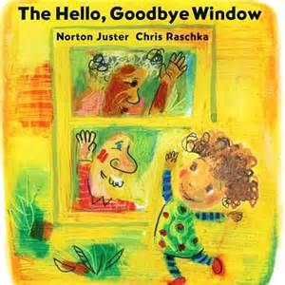](http://www.bing.com/images/search?q=hello+goodbye+window&view=detailv2&&id=C90DC922A9EA81A77FC4FF924133B84FF24102EB&selectedIndex=1&ccid=jVluz7ZO&simid=608011733104003455&thid=JN.P3epcZVzF6HzgfUqF1mqGw)Could be a poem or a booklet format:

My Special Place

I love my (the) \_\_\_\_\_\_\_\_\_\_\_\_\_\_\_\_\_

I see \_\_\_\_\_\_\_\_\_\_\_\_\_\_\_\_\_\_\_

I hear \_\_\_\_\_\_\_\_\_\_\_\_\_\_\_\_\_

I smell \_\_\_\_\_\_\_\_\_\_\_\_\_\_\_\_\_\_

I feel \_\_\_\_\_\_\_\_\_\_\_\_\_\_\_\_\_\_\_

I love my (the) \_\_\_\_\_\_\_\_\_\_\_\_\_\_\_\_\_\_\_\_

* **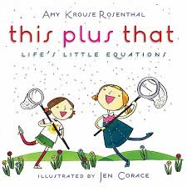**Next Lesson – Use the same format but write about a Season

**This Plus That – Amy Krouse Rosenthal**

[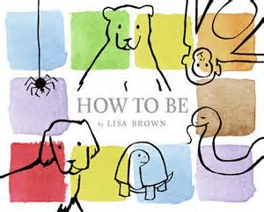](http://www.bing.com/images/search?q=how+to+be+lisa+brown&view=detailv2&&id=ED572CE82007F61B6CD1F8149604A3474E68C6DF&selectedIndex=0&ccid=ntCukXRH&simid=607986036311590138&thid=JN.QQEwezP8OED8JQQ5rzhMbg)Term 3 – Nonfiction Writing

Focus on Animals in the lower mainland – read/research different animals.

Instructional writing – How to books

Anchor Book: ***How to Be*** – by Lisa Brown

How to be a \_\_\_\_\_\_\_\_\_\_\_\_\_\_\_\_\_\_\_\_\_\_ (animal)

Live \_\_\_\_\_\_\_\_\_\_\_\_\_\_\_

Eat \_\_\_\_\_\_\_\_\_\_\_\_\_\_\_

Have \_\_\_\_\_\_\_\_\_\_\_\_\_\_

\_\_\_\_\_\_\_\_\_\_\_\_\_ (special behavior)

Beware \_\_\_\_\_\_\_\_\_\_\_\_

Be \_\_\_\_\_\_\_\_\_\_\_\_\_\_\_\_\_

This Plus That – various activities

**Revisiting Key Ideas:**

* Main Focus – students leave with a passion for writing and some writing tools: triple scoop, anchor lines, walking and climbing stories, adding details”
* **Journal** – provide daily opportunities for writing. Link writing to reading.
* **Writing Center** – stock with a variety of types of booklet shapes, booklet sizes, paper, pencils, felts. Have Author’s Chair there as well!
* If you tell students they are writers – they will believe and become writers!
* Praise, Tips and Encouragement - they go a LONG way!
* LOTS of time to practice – incorporate Writer’s Workshop into Weekly Routine
* MODEL writing in front of students. They need to see you as a writer, too!
* Talk about writer’s craft when reading books aloud: *“I’m noticing that this writer...”*

Happy Writing, Everyone!

4 – Corner Planner

|  |  |
| --- | --- |
|  |  |
|  |  |

Triple Scoop Word Chart

|  |  |
| --- | --- |
| MC900016745[1] Single Scoop | MC900209026[1] Triple Scoop |
| hot | sweltering, melting, scorching, roasting |
| cold |  |
| wet |  |
| fun |  |
| good |  |
| bad |  |
| tired |  |
| hungry |  |
| sad |  |
| happy |  |
| mad |  |
| pretty |  |
| big |  |
| small |  |
| said |  |
| nice |  |
| scared |  |

The OK Book

I’m an OK \_\_\_\_\_\_\_\_\_\_\_\_\_\_\_\_\_\_\_\_\_\_\_\_\_\_\_\_\_\_\_\_\_\_\_\_\_\_\_\_\_\_\_

|  |  |
| --- | --- |
|  |  |

My Color Connections

\_\_\_\_\_\_\_\_\_\_\_\_\_\_\_\_\_\_\_\_\_\_\_\_\_\_\_\_\_\_\_\_\_\_\_\_\_\_\_ \_\_\_\_\_\_\_\_\_\_\_\_\_\_\_\_\_\_\_\_\_\_\_\_\_\_\_\_\_\_\_\_\_\_\_\_\_\_\_

\_\_\_\_\_\_\_\_\_\_\_\_\_\_\_\_\_\_\_\_\_\_\_\_\_\_\_\_\_\_\_\_\_\_\_\_\_\_\_ \_\_\_\_\_\_\_\_\_\_\_\_\_\_\_\_\_\_\_\_\_\_\_\_\_\_\_\_\_\_\_\_\_\_\_\_\_\_\_

\_\_\_\_\_\_\_\_\_\_\_\_\_\_\_\_\_\_\_\_\_\_\_\_\_\_\_\_\_\_\_\_\_\_\_\_\_\_\_ \_\_\_\_\_\_\_\_\_\_\_\_\_\_\_\_\_\_\_\_\_\_\_\_\_\_\_\_\_\_\_\_\_\_\_\_\_\_\_

\_\_\_\_\_\_\_\_\_\_\_\_\_\_\_\_\_\_\_\_\_\_\_\_\_\_\_\_\_\_\_\_\_\_\_\_\_\_\_ \_\_\_\_\_\_\_\_\_\_\_\_\_\_\_\_\_\_\_\_\_\_\_\_\_\_\_\_\_\_\_\_\_\_\_\_\_\_\_

|  |  |
| --- | --- |
|  |  |

My Toy Connections

I can give away… But I can never give away…

\_\_\_\_\_\_\_\_\_\_\_\_\_\_\_\_\_\_\_\_\_\_\_\_\_\_\_\_\_\_\_\_\_\_\_\_\_\_\_ \_\_\_\_\_\_\_\_\_\_\_\_\_\_\_\_\_\_\_\_\_\_\_\_\_\_\_\_\_\_\_\_\_\_\_\_\_\_\_

\_\_\_\_\_\_\_\_\_\_\_\_\_\_\_\_\_\_\_\_\_\_\_\_\_\_\_\_\_\_\_\_\_\_\_\_\_\_\_ \_\_\_\_\_\_\_\_\_\_\_\_\_\_\_\_\_\_\_\_\_\_\_\_\_\_\_\_\_\_\_\_\_\_\_\_\_\_\_

\_\_\_\_\_\_\_\_\_\_\_\_\_\_\_\_\_\_\_\_\_\_\_\_\_\_\_\_\_\_\_\_\_\_\_\_\_\_\_ \_\_\_\_\_\_\_\_\_\_\_\_\_\_\_\_\_\_\_\_\_\_\_\_\_\_\_\_\_\_\_\_\_\_\_\_\_\_\_

**Kindergarten Writing Criteria**

|  |  |  |  |  |
| --- | --- | --- | --- | --- |
|  | **Not Meeting Expectations** | **Approaching Expectations** | **Fully Meeting Expectations** | **Exceeding Expectations** |
| **November** | * No name * Scribble drawing * No recognizable form or shape in drawings | * Draws a recognizable picture and labels orally * Scribbles or uses arbitrary symbols to represent sounds or words. | * Draws a recognizable picture and can tell a story about it. * Uses random letters to represent sounds and words but without letter-sound recognition | * Uses letters and letter strings to represent a story * May be beginning to match a few sounds with letters |
| **February** | * Draws a recognizable picture and labels orally * Scribbles or uses arbitrary symbols to represent sounds or words. | * Draws a recognizable picture and can tell a story about it. * Uses random letters to represent sounds and words but without letter sound accuracy | * Uses letters and letter strings to represent a story * May be beginning to match a few sounds with letters | * Almost every word is consistently represented by at least one sound, sometimes more than one. * Can write a complete thought in sentence form. |
| **June** | * Draws a recognizable picture and labels orally * Scribbles or uses arbitrary symbols to represent sounds or words | * Draws a recognizable picture and labels orally * Uses letter strings to represent sounds or “words” * May be beginning to match a few sounds | * Almost every word is consistently represented by at least one sound, sometimes more than one. * Can write a complete thought in a “sentence” form. * Uses some known high frequency words | * Spells some high frequency words accurately * Puts spaces between some words * Writing can be read by others with little or no difficulty |

|  |  |  |  |  |  |  |
| --- | --- | --- | --- | --- | --- | --- |
| Name : | ME | | | TEACHER | | |
| **C:\Users\pcuser\AppData\Local\Microsoft\Windows\INetCache\IE\UDSURDWI\sad_face[1].jpg** |  | C:\Users\pcuser\AppData\Local\Microsoft\Windows\INetCache\IE\UDSURDWI\FP25C_C_LargeHappyFace[1].jpg | C:\Users\pcuser\AppData\Local\Microsoft\Windows\INetCache\IE\UDSURDWI\sad_face[1].jpg |  | C:\Users\pcuser\AppData\Local\Microsoft\Windows\INetCache\IE\UDSURDWI\FP25C_C_LargeHappyFace[1].jpg |
| I tried to sound out some letters and words on my own. |  |  |  |  |  |  |
| I tried to add one detail to my writing to make it more interesting. |  |  |  |  |  |  |
| I tried to use a triple scoop word in my writing. |  |  |  |  |  |  |
| I tried to remember finger spaces between my words. |  |  |  |  |  |  |

|  |  |  |  |  |  |  |
| --- | --- | --- | --- | --- | --- | --- |
| Name : | ME | | | TEACHER | | |
| **C:\Users\pcuser\AppData\Local\Microsoft\Windows\INetCache\IE\UDSURDWI\sad_face[1].jpg** |  | C:\Users\pcuser\AppData\Local\Microsoft\Windows\INetCache\IE\UDSURDWI\FP25C_C_LargeHappyFace[1].jpg | C:\Users\pcuser\AppData\Local\Microsoft\Windows\INetCache\IE\UDSURDWI\sad_face[1].jpg |  | C:\Users\pcuser\AppData\Local\Microsoft\Windows\INetCache\IE\UDSURDWI\FP25C_C_LargeHappyFace[1].jpg |
| I tried to sound out some letters and words on my own. |  |  |  |  |  |  |
| I tried to add one detail to my writing to make it more interesting. |  |  |  |  |  |  |
| I tried to use a triple scoop word in my writing. |  |  |  |  |  |  |
| I tried to remember finger spaces between my words. |  |  |  |  |  |  |

|  |  |  |  |  |  |  |
| --- | --- | --- | --- | --- | --- | --- |
| Name : | ME | | | TEACHER | | |
| **C:\Users\pcuser\AppData\Local\Microsoft\Windows\INetCache\IE\UDSURDWI\sad_face[1].jpg** |  | C:\Users\pcuser\AppData\Local\Microsoft\Windows\INetCache\IE\UDSURDWI\FP25C_C_LargeHappyFace[1].jpg | C:\Users\pcuser\AppData\Local\Microsoft\Windows\INetCache\IE\UDSURDWI\sad_face[1].jpg |  | C:\Users\pcuser\AppData\Local\Microsoft\Windows\INetCache\IE\UDSURDWI\FP25C_C_LargeHappyFace[1].jpg |
| I tried to sound out some letters and words on my own. |  |  |  |  |  |  |
| I tried to add one detail to my writing to make it more interesting. |  |  |  |  |  |  |
| I tried to use a triple scoop word in my writing. |  |  |  |  |  |  |
| I tried to remember finger spaces between my words. |  |  |  |  |  |  |